Quickstart Guide

**Control** **Panel**: Within the control panel you can define all settings, before you start the simulation via the Play button ( ► ).  
Except for the orbital settings (eccentricity, axial tilt and precession) you can still change them during a simulation run.

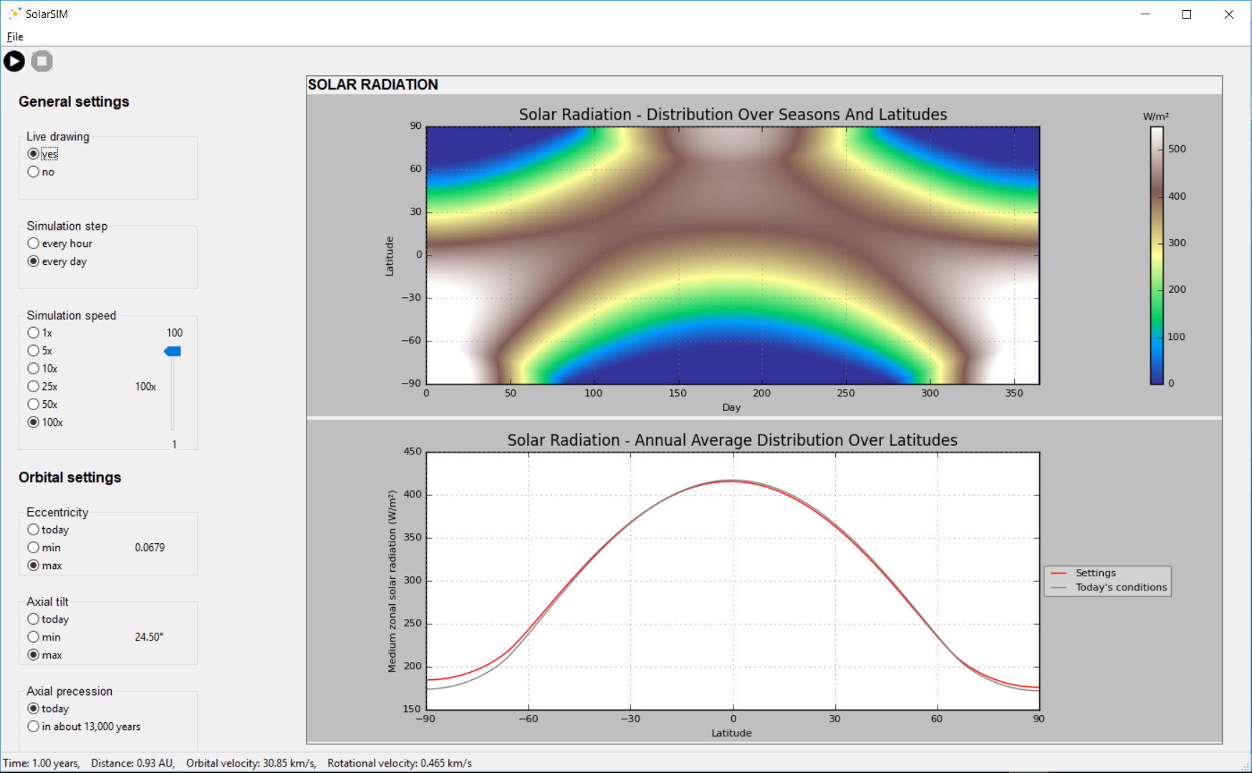

**Statusbar**

The status bar shows the time elapsed in the simulation in years, the distance of the Earth to the Sun in Astronomical Units (AU), the orbital speed and the rotational speed in km/s.

**Solar Radiation – Annual Average Distribution Over Latitudes**

This chart shows the distribution of solar radiation over a year. The red line shows the curve progression for the selected settings; the gray line the standard run with today's orbital configuration.

**Solar Radiation – Distribution Over Seasons And Latitudes**

This chart shows for each day the distribution of solar radiation over the latitudes.

**Start and Stop**

Use the Play and Stop buttons to start or stop the simulation. Warning: If you stop the simulation, it will be reset. Use the spacebar (within the animation) to pause the simulation.

**File**

Under File you have two options: On the one hand, you can use 'Save output' (shortcut Ctrl + S) to save the charts locally on your computer. On the other hand, you can quit the program via 'Quit' (shortcut Ctrl + G).

**Axial precession**

The precession indicates the direction of the Earth's axis in which it is inclined. Every 26,000 years, it points in the same direction again. Therefore, you can choose here between a present state and one in 13,000 years.

**Axial tilt**

The inclination represents the deviation from the ecliptic. Change the inclination of the Earth's axis between 22.10 ° and 24.50 °.

**Eccentricity**

The eccentricity indicates how much the orbit deviates from a perfect circle. Change the eccentricity of the earth between an almost perfect circle with 0.000055 and an ellipse with 0.0679.

**Simulation speed**

With this option you can set the simulation speed. This does not change the step size, but merely reduces the time between two simulation steps.

**Simulation step**

Change this option if you want the calculations to be done once an hour or once a day. With hourly update steps, you can also observe the rotation of the planet around its own axis in the animation screen.

**Live drawing**

Activate this option if the charts should be updated after each time step. However, this slows down the simulation considerably. If deactivated, the data is generated in each time step, but only displayed after the simulation has finished.

Quickstart Guide

**Animation**: This window shows the planets orbiting the sun.  
Depending on the selected setting, even the 24-hour rotation can be observed, as well as the illumination from the sun.

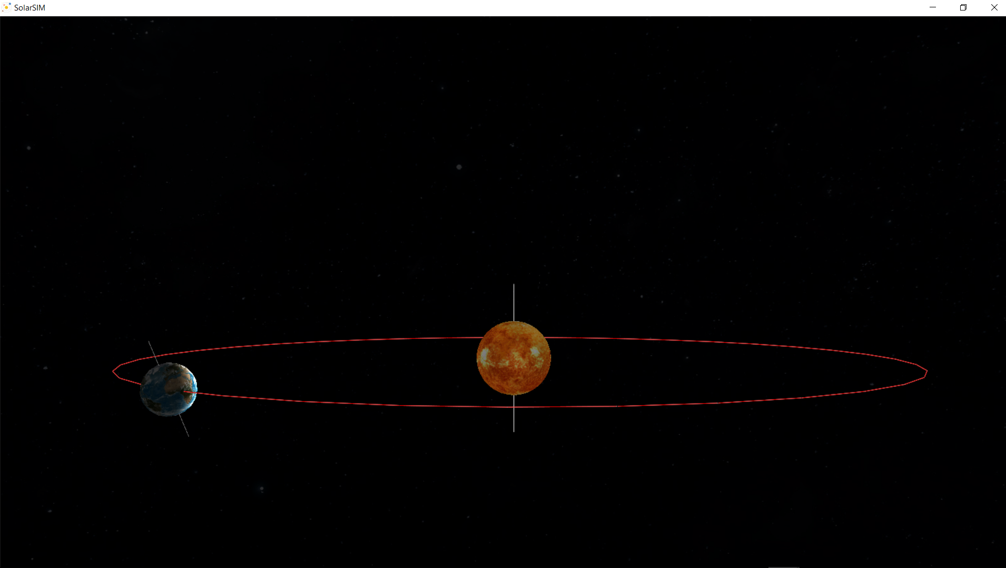

**Milky Way**

In the background you can observe the stars of the Milky Way and search for known sky constellations.

**Orbit**

The orbit that the Earth describes during a complete cycle around the Sun. Depending on the eccentricity, the track is more or less elliptical.

**Earth**

Our blue planet. If you zoom in, you can even observe the incidence of light depending on the position of the sun during the seasons.

**Sun**

Our central star in all its glory. The sun is the primary source of heat and light on the Earth   
- likewise in the simulation.

**Pause**

Press the spacebar once to pause the simulation. If you press the space bar again, the run will continue.

**Zoom**

To zoom in or out of the application, hold down both mouse buttons and move the mouse forward (+) or back (-).

**Move**

To move the screen, click on the desired location. The camera then jumps to this position.

**Rotate**

To rotate the view, press and hold the right mouse button and move the mouse up or down.